The following procedure outlines the steps for supplier companies on how to set up new products and services in their Public Catalog or how to edit and/or delete as necessary. Suppliers must have Corporate Modify permission to create or modify products and services.

- Sign in to OpenInvoice

- Hover over the “Corporate” tab, and select “Products/Services” from the drop-down
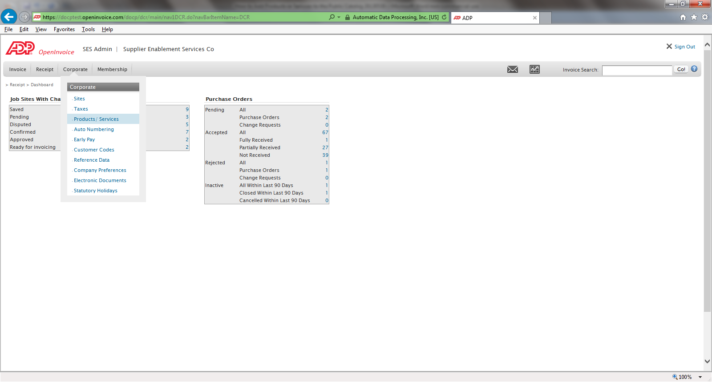

- It is good practice to view the existing Public Catalog (Product/Service list) to ensure you will not be adding a duplicate (data management is very important) and to determine if a standard exists for ‘coding’.
- Using the Filter box, enter a wildcard ‘*” into the “Service Description” field and click “Apply Filter”
  - A more specific search using key words in combination with an asterisk ‘*’
- It is also important to ensure there is a “Default” item selected
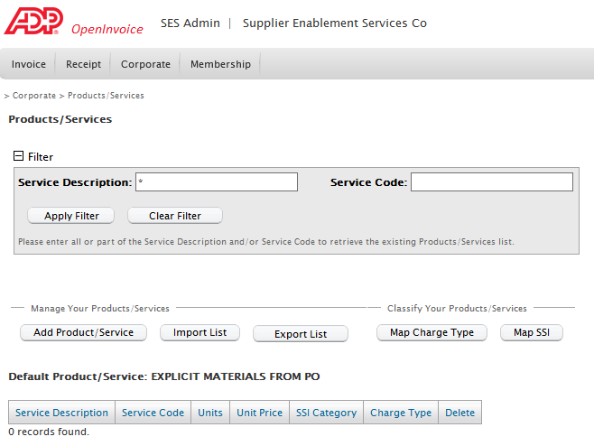

- Once displayed, clicking on a column heading will sort this list in alphanumeric order. Clicking a second time will ‘reverse’ sort the list.
- Either scrolling through the list and/or completing a more detailed search will identify if an item already exists and will identify the “Service Code” standard (e.g. in the list below, the standard is 1001, 1002, 1003, etc. as well as other codes that seem random or may come from an accounting system)
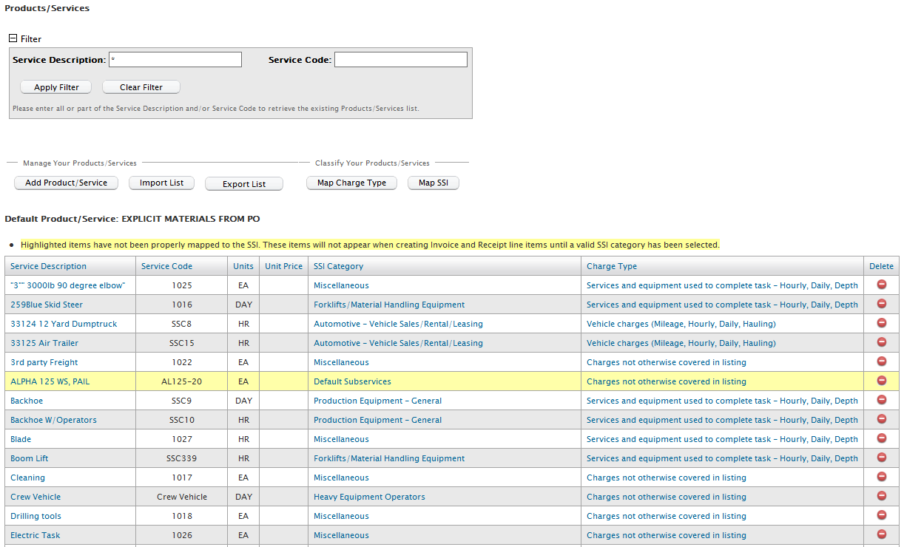

- Click on the “Add Product/Service” Button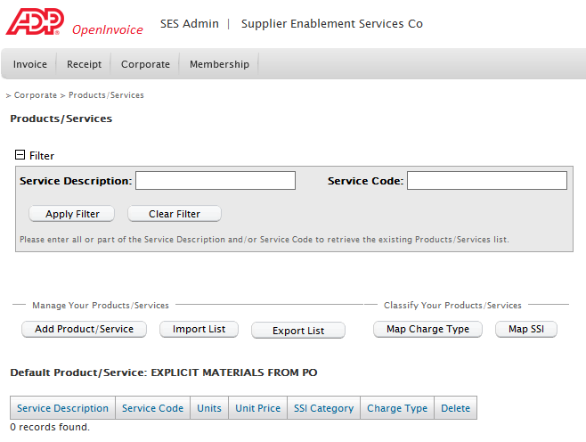

- The “Product/Service Profile” screen will be displayed.
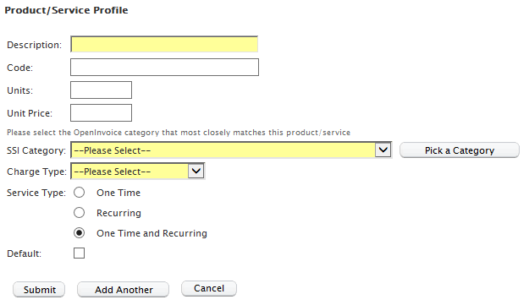

Complete the following fields

Description: Enter a description of the product or service exactly as you’d like it to appear in the drop-down when selecting from your Public Catalog during eFT Creation (Charge Wizard)

Code: Enter a UNIQUE code (can be numbers and letters) that identifies this specific item. It is recommended that you use the assigned codes for products and services from your accounting system (each code must be unique). If your accounting system does not have item codes, use a standardized system to create unique codes and enter the next sequential code for each subsequent addition. To view existing codes, display the full list by using a wildcard ‘*’ in the search box shown above.

Units: Enter the Hess unit of measure (See List of Hess Approved Units of Measure for details).

SSI Category: If one does not default, choose the most appropriate from the drop down list.

Charge Type: Choose the most appropriate from the drop down list.

Service Type: Do not change the default (should be “One Time and Recurring”).

Click Submit to complete the addition or Add Another to continue adding new products and services.

Edit and or delete product and services using the same screen.

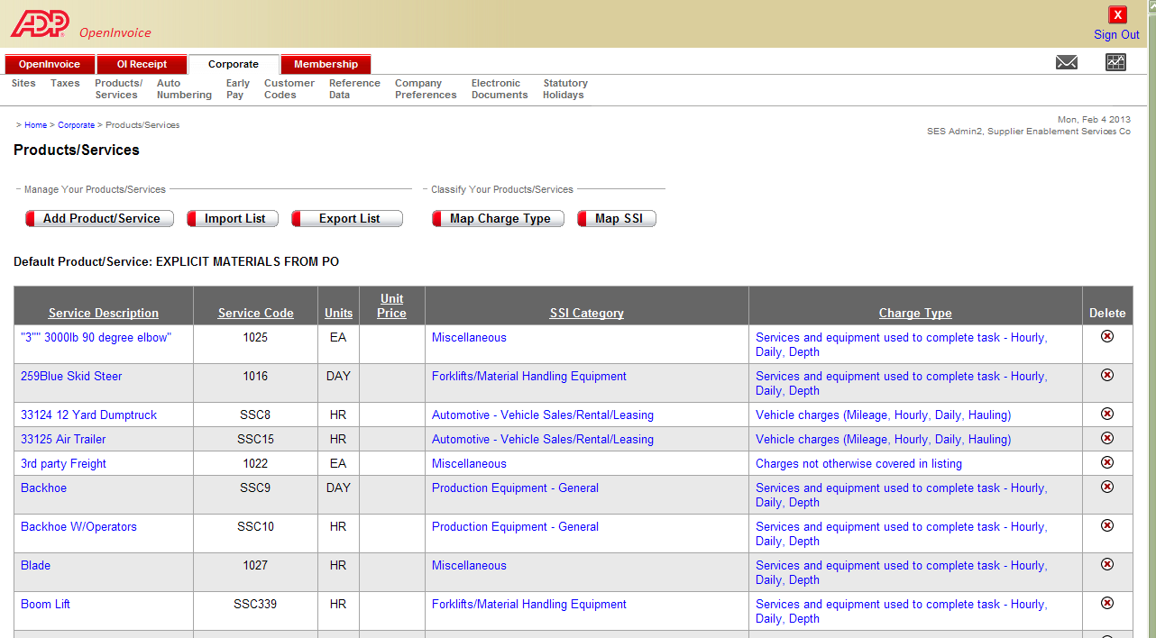
Edit
Delete

Delete a Product or Service by clicking on the Delete button in the last column on the right hand side of the screen.

Edit a Product or Service by clicking on the Service Description in blue and making the required changes on the Product and Service Profile Screen.

How to MASS UPLOAD items to your catalog using catalog TEMPLATE:

- Prepare your Catalog Template.
- Fill in the Service Description and Service Code and put “ADD” in the ‘action’ column. See below.
- Leave Columns B, C & F Blank.
- Leave all columns in place. Do not edit the header in any way.

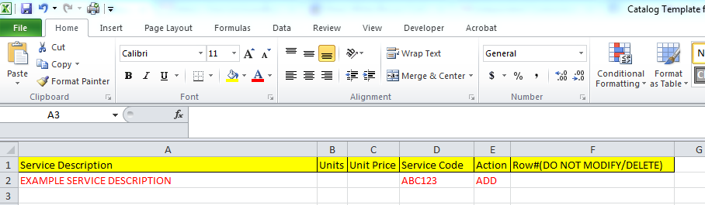

In your ADP Dashboard, hover over ‘Corporate’ until the dropdown menu appears, then click on ‘Products/Services’- see below:

Click on ‘Import List’
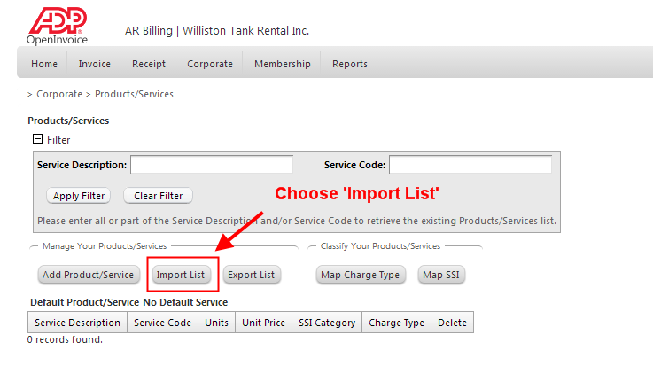

Choose ‘Copy/Paste’ to make the paste box appear. See below:
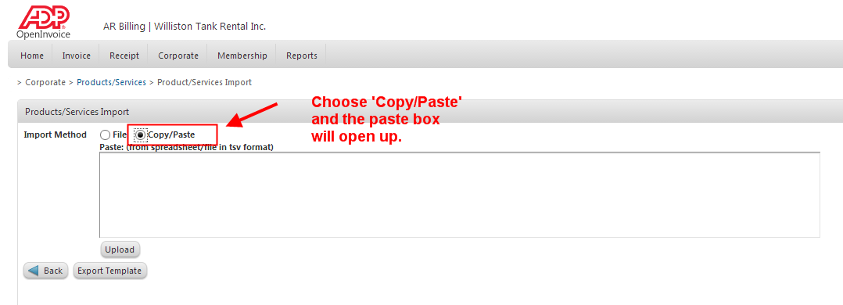

From your catalog template (example below), only highlight & copy columns/rows that are utilized. In this instance it is columns A-F and row 2.
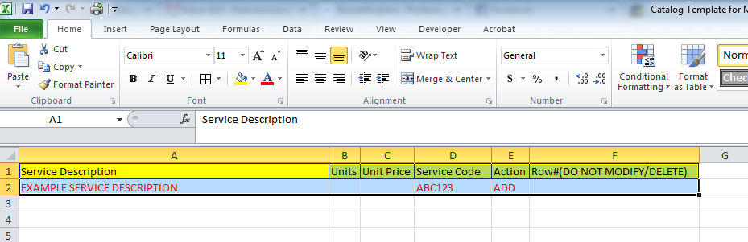

Copy/Paste above info into the provided field in ADP.

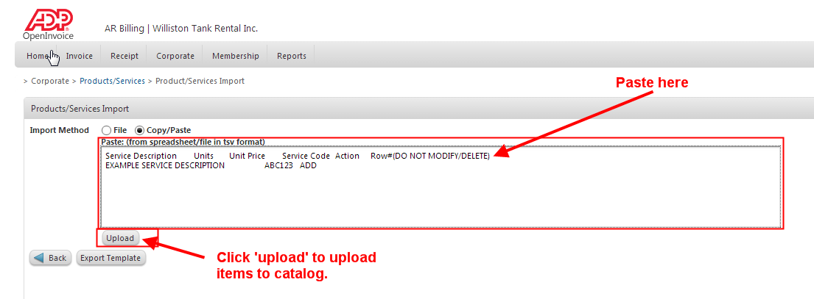

You have successfully imported your catalog items when this message appears:

